**Ansible Playbooks:**

* Always ansible playbook should start with --- (minus symbol)
* Generally the file starts with three minus
* This --- is a requirement to YAML interpreter the file as a proper document
* YAML allows multiple documents to exist in one file each separated by --- (triple -)

**For Example:**

#vi Install.yml

---

Here you can write playbook for installation any package (Playbook1)

---

Configuration (Playbook 2)

---

--------------------------------------------------------------------------

* Hosts declaration should be mandatory for all the playbooks

Syntax: - host: (Host group name) as per your inventory file

Now this playbook will run on list of servers which are comes under (hostgroupname)

* Host declaration is nothing but it defines that on which servers group this playbook should run

**Playbook Syntax:**

* After host declaration you can have other parameters like Variables, Tasks , Name, Actions, Notify, Handlers, Remote users which all depends on the requirement
* Each playbook will have a tasks to carried out on the client system

**Tasks:** under the task your going to specified the list of tasks to be carried out on your client systems

* Every task should have a name

🡪Installing one package is one task (httpd)

🡪Copying file is another task

🡪Starting servers is a another task

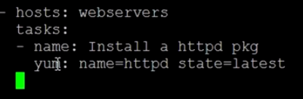 This is one task

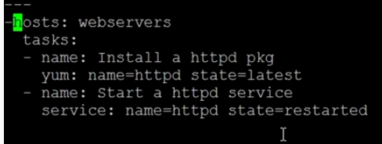 Here another task has been defined now we can see two tasks in the above playbook

Playbook Example 1:

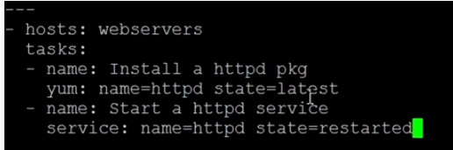

Output:

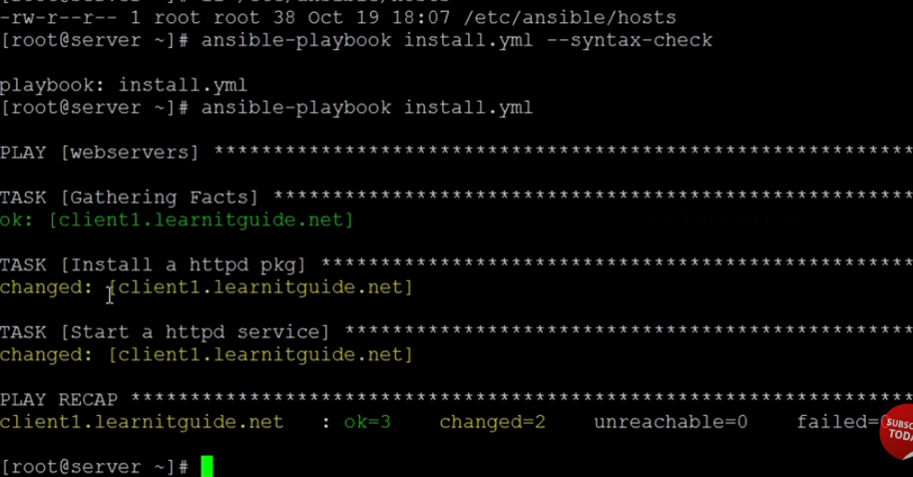

* If you don’t specify any host inventory file then what will happen by default this playbook will go and find the host group on your default host inventory file
* **ll /etc/ansible/hosts**

**Playbook Example 2:**

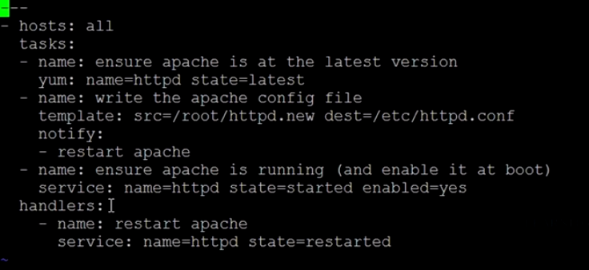

**Template:** ( template will do action like copy ) either you can use module template or copy for this kind of transferring a file

**Notify:**

* notify is reference to a handlers
* Use some name for notify and use the same name for handlers if not then it won’t work
* Handlers also like task

If you are not sure about value of module like state, name then you can get a help by following the below command

**#ansible-doc –l |more** 🡪 If you hit this command it will display lot of modules

Help of particular module

**#ansible-doc yum (module name)**

If you want to check what host group would be effected by a playbook before run the playbook

**#ansible-playbook install.yml –list-hosts**

